Australian Islamic College (Kewdale)

Semester One Examination, 2017

Question/Answer booklet

MATHEMATICS

SOLUTIONS
APPLICATIONS
UNIT 3

Section One:

Calculator-free

Student Number: In figures

In words

Your name

Time allowed for this section
Reading time before commencing work: five minutes
Working time: fifty minutes

Materials required/recommended for this section
To be provided by the supervisor
This Question/Answer booklet
Formula sheet

To be provided by the candidate
Standard items: pens (blue/black preferred), pencils (including coloured), sharpener, correction fluid/tape, eraser, ruler, highlighters

Special items: nil

Important note to candidates
No other items may be taken into the examination room. It is your responsibility to ensure that you do not have any unauthorised material. If you have any unauthorised material with you, hand it to the supervisor before reading any further.

Structure of this paper

Section | Number of questions available | Number of questions to be answered | Working  time (minutes) | Marks available | Percentage of examination
Section One:  Calculator-free | 7 | 7 | 50 | 52 | 35
Section Two:  Calculator-assumed | 11 | 11 | 100 | 98 | 65
 |  |  |  | Total | 100

Instructions to candidates

1. The rules for the conduct of examinations are detailed in the school handbook. Sitting this examination implies that you agree to abide by these rules.

2. Write your answers in this Question/Answer booklet.

3. You must be careful to confine your response to the specific question asked and to follow any instructions that are specified to a particular question.

4. Additional working space pages at the end of this Question/Answer booklet are for planning or continuing an answer. If you use these pages, indicate at the original answer, the page number it is planned/continued on and write the question number being planned/continued on the additional working space page.

5. Show all your working clearly. Your working should be in sufficient detail to allow your answers to be checked readily and for marks to be awarded for reasoning. Incorrect answers given without supporting reasoning cannot be allocated any marks. For any question or part question worth more than two marks, valid working or justification is required to receive full marks. If you repeat any question, ensure that you cancel the answer you do not wish to have marked.

6. It is recommended that you do not use pencil, except in diagrams.

7. The Formula sheet is not to be handed in with your Question/Answer booklet.

Section One: Calculator-free 35% (52 Marks)
This section has seven (7) questions. Answer all questions. Write your answers in the spaces provided.

Working time: 50 minutes.

Question 1 (4 marks)
A graph is shown below.

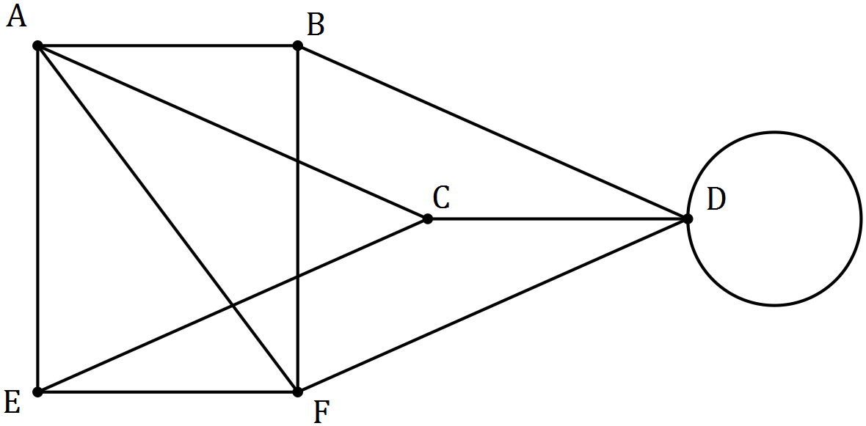

(a) Redraw the graph to clearly demonstrate that it is planar. (2 marks)
Solution
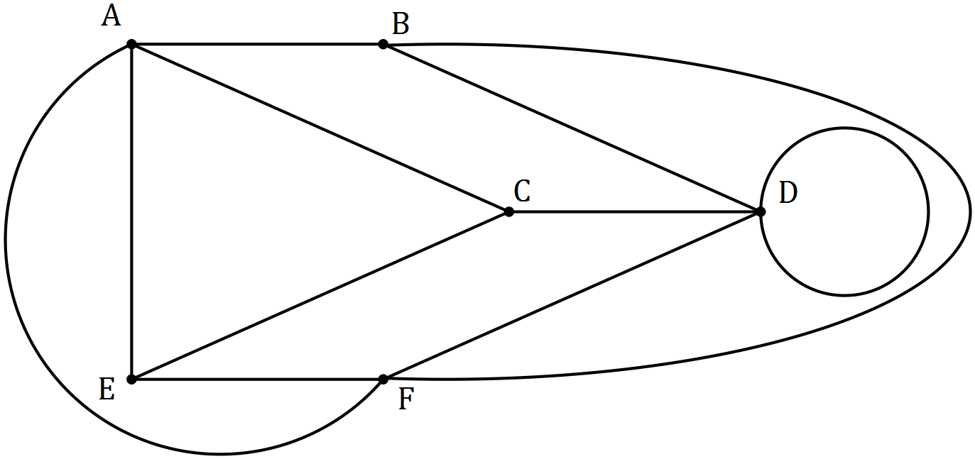

Specific behaviours
redraws AF
redraws BF

(b) Verify Euler's formula for the graph. (2 marks)
Solution
$$E=11, V=6, F=7$$

$$V+F-E=6+7-11=2$$
$$\text{Hence obeys Euler's formula}$$

Specific behaviours
indicates number of edges, vertices and faces
verifies Euler's formula

Question 2 (5 marks)
Ten students were set a challenge in which they had to run through an obstacle course and solve problems at various locations along the way to score points. Their times, in minutes, and total scores are shown in the table below.

Student | 1 | 2 | 3 | 4 | 5 | 6 | 7 | 8 | 9 | 10
Time ($x$) | 34 | 33 | 24 | 26 | 30 | 28 | 31 | 30 | 23 | 25
Score ($y$) | 19 | 19 | 31 | 30 | 24 | 27 | 21 | 28 | 33 | 34

(a) Construct a scatterplot on the axes below that can be used to identify whether any association exists between the variables. (3 marks)

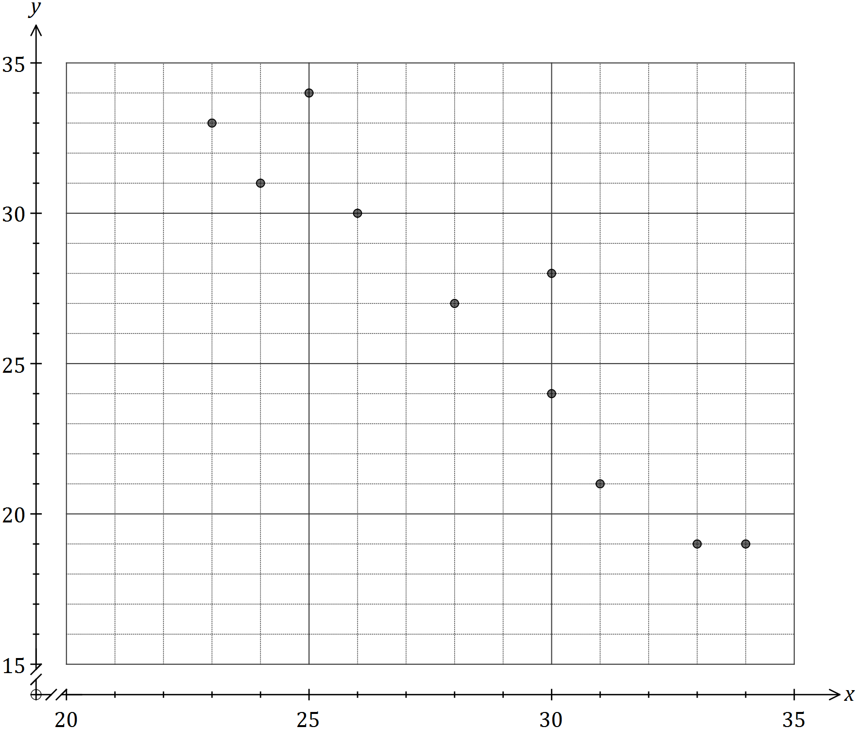
Solution
See graph
Specific behaviours
at least four points plotted correctly
at least eight points plotted correctly
all points plotted correctly

(b) Describe the association between the two variables, $x$ and $y$. (2 marks)
Solution
Strong, negative, linear association

Specific behaviours
two of strength, direction, form
all three indicators

Question 3 (7 marks)
The scatterplots for three sets of data, $A$, $B$ and $C$ are shown below.

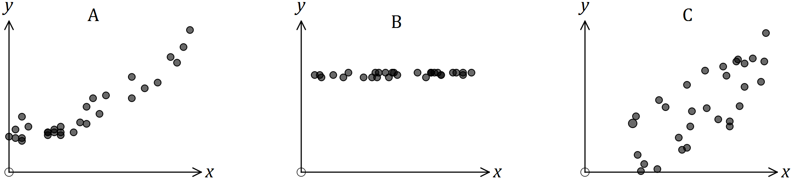

(a) Order the data sets, from strongest to weakest, in terms of the strength of the linear correlation coefficient between the variables. Explain your answer. (3 marks)
Solution
$ACB$
$B$ must be last, as little association is evident between $x$ and $y$ - as $x$ changes, $y$ does not appear to.
Points in $A$ lie closer to a straight line than $C$.
(NB $r_{A}≈0.9, r_{B}≈0.4, r_{C}≈0.7$)

Specific behaviours
order
reason for B last
reason for A first

(b) One of the relationships appears to be non-linear. Identify this data set and explain your choice. (2 marks)
Solution
$A$
Points appear curved, bowing upwards.

Specific behaviours
chooses $A$
indicates curve

(c) Give one example of a pair of possible variables for dataset $B$, explaining your choice.
(2 marks)
Solution
Examples: Day of month v weight; Age v income for adults employed in same job; and so on.
As one increases, it would be reasonable to expect the other to not change.

Specific behaviours
clear example of two variables
explains as one increases other would stay the same

Question 4 (13 marks)
Consider the recursive rule $T_{n+1}=aT_{n}+b, T_{1}=32$, where $a$ and $b$ are both constants.

(a) If $a=\frac{1}{2}$ and $b=0$, determine

(i) $T_{3}$. (1 mark)
Solution
$$\frac{1}{2}×32=16,\frac{1}{2}×16=T_{3}=8$$

Specific behaviours
states value

(ii) a rule for the $n^{th}$ term of the sequence. (2 marks)
Solution
$$T_{n}=32{\left(\frac{1}{2}\right)}^{n-1}$$

Specific behaviours
uses form of equation
uses correct values

(iii) the value of $n$ if $T_{n}=\frac{1}{4}$. (1 mark)
Solution
$$32, 16, 8, 4, 2, 1,\frac{1}{2},\frac{1}{4}⇒n=8$$

Specific behaviours
states value

(b) If $a=1$ and $b=4$, determine

(i) $T_{2}$, $T_{3}$ and $T_{4}$. (2 marks)
Solution
$$T_{2}=32+4=36, T_{3}=36+4=40, T_{4}=40+4=44$$

Specific behaviours
determines $T_{2}$
determines all terms

(ii) a rule for the $n^{th}$ term of the sequence. (2 marks)
Solution
$$T_{n}=32+(n-1)(4)$$

Specific behaviours
uses correct form of equation
uses correct values

(iii) $T_{101}$. (1 mark)
Solution
$$T_{101}=32+100×4=432$$

Specific behaviours
correct value

(c) If $a=\frac{1}{2}$ and $b=4$, determine

(i) $T_{2}$ and $T_{5}$. (2 marks)
Solution
$$T_{2}=\frac{1}{2}\left(32\right)+4=20$$
$$T_{3}=14, T_{4}=11, T_{5}=9.5$$

Specific behaviours
determines $T_{2}$
determines $T_{5}$

(ii) the value $T_{n}$ approaches as $n$ becomes very large. Justify your answer. (2 marks)
Solution
$$x=\frac{1}{2}x+4$$
$$\frac{1}{2}x=4⇒x=8$$
$$T_{n} \text{will approach} 8$$

Specific behaviours
indicates equation for steady state
solves equation

Question 5 (6 marks)
(a) A manager must allocate three new staff members ($S_{1}, S_{2}, S_{3}$) to four vacant desks ($D_{1}, D_{2}, D_{3}, D_{4}$) in an office.

(i) Draw a bipartite graph to show all possible allocations. (2 marks)
Solution
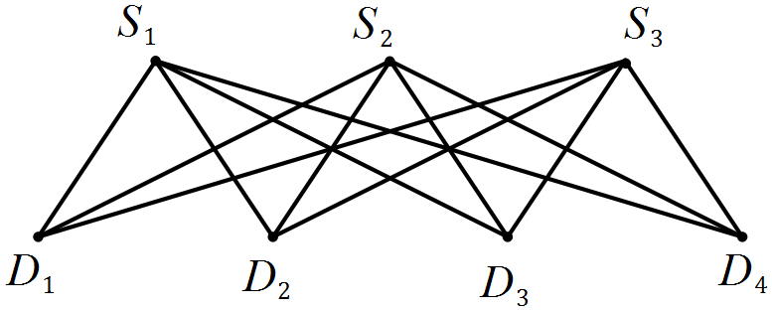

Specific behaviours
two labelled sets of vertices
all 12 edges

(ii) The graph drawn in (i) is an example of a complete bipartite graph. Briefly explain the meaning of complete in this context. (1 mark)
Solution
Every vertex of the first set (staff) is connected to every vertex of the second set (desks)
Specific behaviours
clear explanation

(b) In this adjacency matrix, A, B, C and D represent four drivers and 1, 2, 3 and 4 represent four vehicles they can drive.
 | 1 | 2 | 3 | 4
A | 0 | 1 | 1 | 1
B | 0 | 0 | 1 | 0
C | 0 | 0 | 1 | 0
D | 1 | 1 | 1 | 1

(i) Draw a bipartite graph to represent the adjacency matrix. (2 marks)
Solution
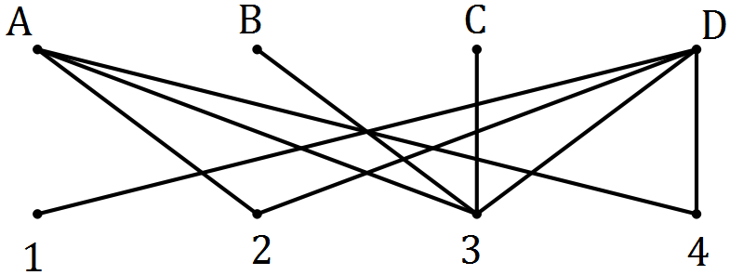

Specific behaviours
two labelled sets of vertices
all 9 edges

(ii) Use your graph to explain why all four drivers cannot all be driving a vehicle at the same time. (1 mark)
Solution
B and C can only drive vehicle 3. So if one is driving, the other cannot.
Specific behaviours
clear explanation

Question 6 (6 marks)
The scatterplot below illustrates how the number of firefighters sent to fires ($x$) is related to the cost of the damage ($y$) resulting from the fire, in a large city.

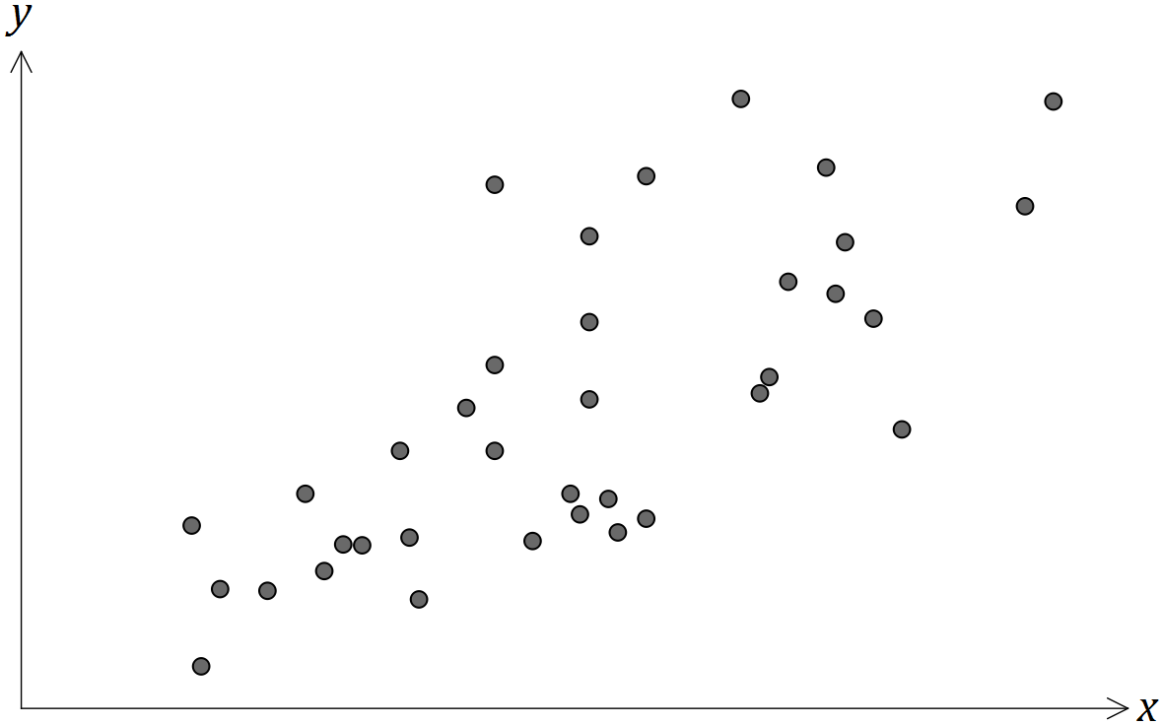

(a) Place a cross on the scale below for the best estimate of the correlation coefficient between the two variables. Explain your choice. (2 marks)

Solution
See line. A fairly strong, positive relationship is shown.

Specific behaviours
indicates value between 0.6 and 0.9
comment indicates strength and direction

(b) Is it reasonable to conclude from the scatterplot that sending fewer firefighters to a fire will decrease the cost of the damage? Explain your answer. (2 marks)
Solution
No.
An observed association does not mean a causal relationship exists.

Specific behaviours
indicates NO
explains no causal relationship

(c) Identify and explain a possible non-causal explanation for the observed association between the number of firefighters and the cost of the damage. (2 marks)
Solution
The size of the fire.
A larger fire is likely to cause greater damage and require more fireman to put it out.

Specific behaviours
identifies third variable
explains likely cause of association

Question 7 (11 marks)
(a) Next to each vertex on the graph below, write whether it is odd or even. (2 marks)

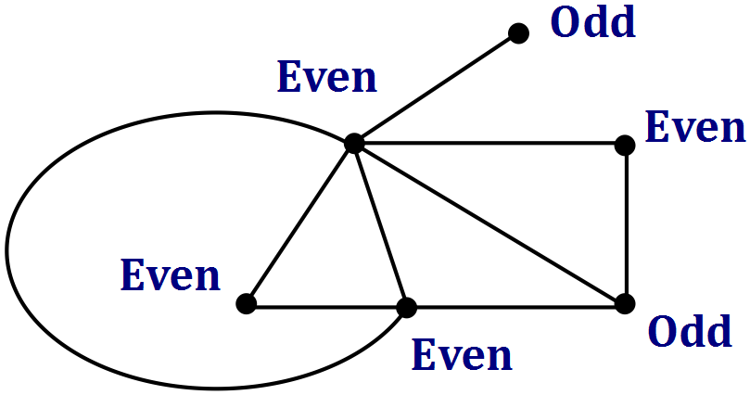
Solution
See graph
Specific behaviours
all evens
all odds

(b) Draw, if possible, a connected graph with at least two vertices that has the following properties. If not possible, explain why.

(i) The sum of the degrees of the vertices is 6. (2 marks)
Solution
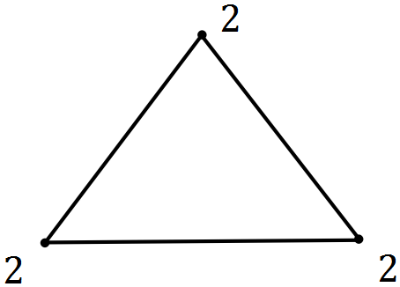

Specific behaviours
connected graph with at least two vertices
an even number of odd vertices

(ii) The sum of the degrees of the vertices is 9. (2 marks)
Solution
Not possible.
Sum of degrees will always be even. (All edges have two ends)

Specific behaviours
states not possible
reason

(c) A simple connected graph has seven vertices, one of which has degree $x$.

(i) State the smallest and largest possible values of $x$. (2 marks)
Solution
$$x_{min}=1$$
$$x_{max}=6$$

Specific behaviours
correct min
correct max

(ii) The seven vertices have the degrees shown below.

$$x, x-1, x-3, 2x-5, 2x-6, 2x-8, 4x-14$$

Determine the value of $x$, justifying your answer. (3 marks)
Solution
$$\text{Sum of degrees}=13x-37$$
$$\text{Sum must be even, so} x=1, 3 \text{or} 5$$
$$x=1, 4x-14=-10 ∴\text{can't be 1}$$
$$x=3, 4x-14=-2 ∴\text{can't be 3}$$
$$\text{Hence} x=5$$

Specific behaviours
eliminates at least two possibilities, with reasoning
eliminates another two, with reasoning
deduces correct value

Additional working space

Question number: _________

Additional working space

Question number: _________

Additional working space

Question number: _________

Additional working space

Question number: _________

© 2016 WA Exam Papers. Australian Islamic College (Kewdale) has a non-exclusive licence to copy and communicate this paper for non-commercial, educational use within the school. No other copying, communication or use is permitted without the express written permission of WA Exam Papers. SN209-096-2.

